With original data:

est_gp = SymbolicRegressor(population_size=1000,

generations=50, stopping_criteria=0.25,

p_crossover=0.8, p_subtree_mutation=0.05, function_set=function_set,

p_hoist_mutation=0.10,

p_point_mutation=0.05,

max_samples=0.75, verbose=1,

parsimony_coefficient=.5, random_state=0)

0.647

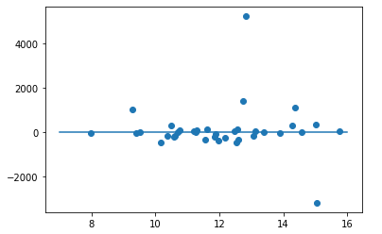

With trimmed data plus PC = .5:

est_gp = SymbolicRegressor(population_size=1000,

generations=50, stopping_criteria=0.25,

p_crossover=0.8, p_subtree_mutation=0.05, function_set=function_set,

p_hoist_mutation=0.10,

p_point_mutation=0.05,

max_samples=0.75, verbose=1,

parsimony_coefficient=.5, random_state=0)

0.395

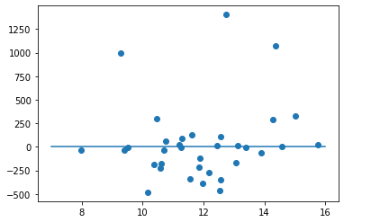

With default parameters:

est_gp = SymbolicRegressor(population_size=1000,

generations=50, stopping_criteria=0.25,

p_crossover=0.9, p_subtree_mutation=0.01, function_set=function_set,

p_hoist_mutation=0.01,

p_point_mutation=0.01,

max_samples=0.90, verbose=1,

parsimony_coefficient=.001, random_state=0)

div(0.806, 0.883)

= 0.912797281993205

R2: -0.006164543491346208

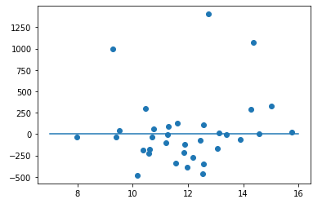

est_gp = SymbolicRegressor(population_size=1000,

generations=50, stopping_criteria=150,

p_crossover=0.8, p_subtree_mutation=0.05, function_set=function_set,

p_hoist_mutation=0.1,

p_point_mutation=0.01,

max_samples=0.90, verbose=1,

parsimony_coefficient=.001, random_state=0)

sub(mul(div(mul(neg(0.762), sub(X0, 0.463)), -0.199), inv(sub(X0, 0.842))), X0)

= (-X0*(X0 - 0.842) + 3.82914572864322*X0 - 1.77289447236181)/(X0 - 0.842)

R2: -0.011402445225793256

